**JOB DESCRIPTION**

|  |  |
| --- | --- |
| **Job Title:** | Programme Manager |
| **Rank/Band:** | Band A |
| **Line Management:** | Head of Project & Programme Management Services |
| **Vetting Level** | DV |
| **STRAP Required** | Yes |

**Job Summary**

Working within the Counter Terrorism Policing Headquarters (CTPHQ) Change Pillar, the Programme Manager will be responsible for the successful delivery of a National and/or London Counter Terrorism and Protective Security (CT & PS) complex change programme, as deployed by the Head of Project & Programme Management Services (PPMS). The Programme Manager will routinely be matrix-managed: line managed by Head of PPMS, but also held responsible by the respective programme SRO and board for the overall delivery of a given programme. The post holder will provide oversight of multiple programmes/projects at any time depending on the scale and complexity of change involved. The post holder may also work on collaborative / joint programmes with our CT partner agencies.

**Role Position within CTPHQ Change Pillar**

The Change Pillar manages the delivery of the Counter Terrorism (CT) and Protective Security (PS) Policing Change Portfolio to meet our strategic objectives. It is split into 4 teams; Project and Programme Management (PPM), Portfolio Management, Change Management, and Business Design.

The Programme Manager will work closely with other Programme Managers, the Head of Portfolio Management Office, Senior Responsible Owners (SROs) / Programme Directors (for significant change programmes) and other CTPHQ Unit Heads, e.g. Head of Strategy and Head of Finance. The Programme Manager will be responsible for establishing an appropriately scaled and costed delivery team. In time of high demand for change, the Programme Manager may work with and acquire other external contractors, contingent labour and consultancy services to support work demands. In their role as Programme Manager a dedicated Programme Management Office, as well as other enabling support such as benefits and change managers from the PfMO, may also support them.

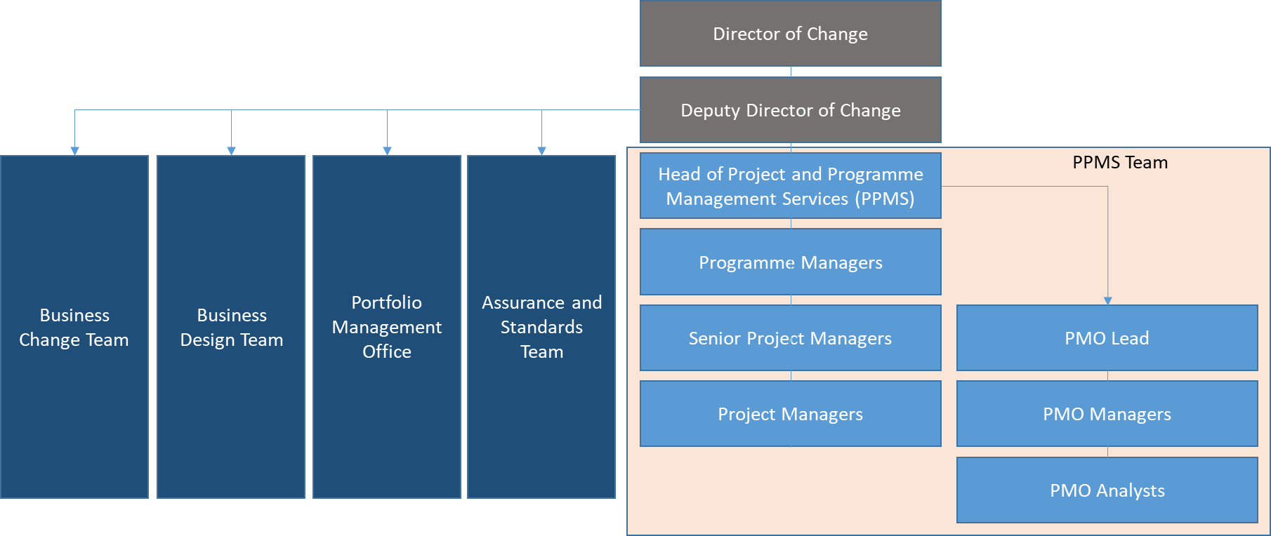

**Job Purpose:**

The purpose of this role is to provide day-to-day management and leadership of complex programmes, projects and project teams across the change lifecycle within a dynamic and flexible environment, to agreed parameters (time, cost, quality).

**Key Responsibilities**

* Responsible for the successful delivery of specific National and/or London Counter Terrorism and Protective Security change programmes, as deployed by the CTPHQ Head of PPMS.
* Ensure the implementation of programme and project management standards, processes and product sets (as defined by the CTPHQ Portfolio Office Centre of Excellence) across the change programmes and projects within direct responsibility including any independent quality assurance activity.
* To ensure the programmes and projects within direct responsibility maintain a defined standard of PPM maturity, as directed and monitored by the CTPHQ Portfolio Office.
* Construct, manage and own their programme plans and schedules, and manage the key internal and external dependencies & constraints across these.
* Resource and then task manage the programme team(s) to ensure deliverables and outcomes are met as defined by the business case and to time, cost and quality parameters.
* Responsible for successful transition of deliverables into BAU – as defined by approved design and business cases(s).
* Identify key issues and resolutions and escalate through programme and business forums where appropriate.
* Ensure change programmes remain aligned with the strategic objectives and the target-operating model for CT Policing.
* Leading on the stakeholder engagement and management in respect of the programmes the post holder has responsibility for.
* Develop programme level business cases (as designed by the CTPHQ project and programme lifecycle), coordinate approvals and sign off for business cases and their subsequent successful delivery.
* Identify constraints within their change programmes such as funding or resources and work with the CTPHQ Head of PPMS to overcome them.
* Work flexibly across the National and London CT Policing change portfolio as required by the CTPHQ Head of PPMS.
* Line management of PPM staff members including performance management and review, career pathway development, attendance management. Provide leadership, advice and support to direct reports and develop individuals and staff to establish a highly performing team and therefore the successful delivery of performance objectives.
* Tangible contribution to the continuous improvement of the CTP Change Pillar and its related performance, as defined by annual individual Personal Performance Development Review (or equivalent as applicable).

**Skills**

|  |  |  |  |
| --- | --- | --- | --- |
| **Advanced: Highly competent in this skill and could train and/or coach others** | | | |
| * Stakeholder Management | * PPM Planning & Dependency Management | * Business Case Writing | * PPM Resource planning & forecasting |
| * Project Management | * RAID Log Management | * Business Case Assurance | * PPM Resource tracking |
| * Project Scoping & Design | * PPM Benefits Management | * Stage-Gate Assurance | * PPM Resource prioritising & scheduling |
| * Commercial & procurement management | * PPM Benefits mapping and profiling | * PPM Governance Design | * PPM Financial management and forecasting |
| * PPM Risk Management | * PPM Benefits planning and tracking | * PPM Governance Management | * Use of Portfolio Office templates |
| * PPM Risk Analysis & reporting | * Management and Status Reporting | * PPM Change Control | * Workshop design |
| * PPM Risk Contingency planning | * Collecting and analysing quantitative and qualitative data | * Assurance of Business Change activity | * Support and Facilitation of Workshops |
| * PPM Issue Management | * Analysing options to support Decision-makers | * Interviewing | * Action tracking & management |
| * Presentation & Verbal Communications skills | * Creative Thinking (Problem Solving) | * Minute Taking | * PPM Mgmt report & dashboard design |
| **Intermediate: Executes the skill competently with minimal supervision** | | | |
| * PPM Reporting data collection & analysis | * Microsoft Project | * Microsoft SharePoint | * Microsoft PowerPoint |
| * Programme Management | * Microsoft Excel | * Microsoft Visio | * Microsoft Word |
| **Foundation: Can execute skill with support** | | | |
| * Portfolio Analysis | * Portfolio Balancing and Prioritisation | * Use of Portfolio Management tools | * Portfolio Management |
| * Portfolio Office SLA Definition & Management |  |  |  |

**Additionally;**

* Excellent managerial and leadership skills.
* Strong situational awareness, able to tailor style and approach to a variety of situations, and comfortable of working with a degree of ambiguity or uncertainty.
* Ability to self-task based on strategic direction, ensuring the delivery of the given scope of work of their programme(s), on time and to budget in accordance with the programme plan.
* Strong negotiating and influencing skills at a senior (Director) level, geared to deliver outcomes.
* Effective communication skills, both verbal and written, and stakeholder engagement skills including experience in developing briefings for senior management.
* Ability to communicate with staff at all levels across the organisation, at both the strategic and tactical level.
* Strong business acumen and situational awareness.
* Analytical and problem-solving skills required to troubleshoot issues within programmes.
* Highly organised and able to meet demanding deadlines in a pressured environment.
* Strong IT skills in the use of Microsoft Products, including project / programme management software (e.g. Microsoft Project).

**Essential Experience**

* Previous experience of working in (local) government, a security agency or policing is essential.
* Experience of working in and delivering collaborative/joint programmes into multiple business units / businesses, with hybrid team construct.
* Experience in managing a business change driven programme, enabled by technology, and successfully delivering service improvements (effectiveness) and/or cost reduction (efficiencies).
* Operating within a project / programme delivery environment with personal responsibility for delivering against a defined plan, including tranche, release and phase management.
* Experience in establishing an effective governance model, defining and implementing impactful stakeholder management strategies and supporting communications plans.
* Experience of actively and effectively managing risks, issues, dependencies, and assumptions – and applying strong change control – at a programme level.
* Experience in supplier and contract management, in a change programme context, including, but not limited, to defining requirements, supplier selection / vfm, contract management planning - definition and application, supplier performance management and closure.
* Knowledge and experience in applying programme and project management approaches such as MSP, PRINCE2 or Agile, specifically the processes and techniques involved in planning, forecasting, managing, and controlling large areas of work.
* Experience in business case development and assessment, planning and the application of good practice processes, and subsequent business case delivery, including benefits realisation management.
* Experience in programme transition to BAU, including implementation of related service management deliverables in accordance with respective design and business case.
* Experience in working across multiple lifecycle frameworks: change, business design / operating model development, technology / engineering development and delivery, and estate planning / delivery.

**Desirable Experience**

* An understanding and knowledge of CT Policing is desirable.
* Experience in a breadth of applying traditional ‘waterfall’ and more iterative ‘agile’ delivery approaches would be desirable, noting depth of delivery experience remains the prime requirement.

**Qualifications**

*Essential***:**

* + - Managing Successful Programme (MSP): Advanced Practitioner or Practitioner (or recognised industry equivalent qualification).

*Desirable***:**

* + - PRINCE2: Practitioner (or recognised industry equivalent qualification).
    - Contract Management: Foundation Course.
    - Agile Project Management Foundation & Practitioner (AgilePM) or PRINCE2 Agile (or recognised industry equivalent).
    - ITIL Foundation Certification.

**Vetting**

* DV clearance is required, and individuals must be prepared to go through the DV process. Where SC is held already, there may be opportunity for the individual to start on a risk managed basis whilst DV is undertaken,
* Candidates must be prepared to go through and successfully obtain additional security clearance, known as STRAP, if required.

**Behaviours:**

*Met Police Competency Values Framework*

Cluster – Resolute, compassionate and committed

* We are emotionally aware – Level
* We take ownership

Cluster – Inclusive, enabling and visionary leadership

* We are collaborative
* We deliver, support, and inspire

Cluster – Intelligent, creative and informed policing

* We analyse critically
* We are innovative and open minded

Met Values

* Professionalism
* Integrity
* Courage
* Compassion